GRAFTING THE FUTURE:

Periodontal Therapies, Guided Tissue Regeneration, and Materials Selection

Jennifer Mathis, DVM, CVPP

Periodontal disease (PD) is the most common disease in dogs and cats.1,2 It is considered preventable in most instances, but due to its often hidden nature, lack of outward clinical signs, and diminished client realization of the need for management, pets are 5 times more likely to have periodontal disease than humans.3 It is known that PD incidence increases with age.2,4,5 The prevalence of periodontal attachment loss has been shown to be 80-87% in dogs aged three years and above and 53% in a population of dogs aged one to two years.5

Periodontal disease is staged based on the amount of bone loss surrounding a tooth root. Should one root of a multirooted tooth have more bone loss than the other, the PD classification is based on the worst root. To review: PD1 = no attachment loss (gingivitis, reversible); PD2 = < 25% attachment loss; PD3 = 25-50% attachment loss or stage 2 furcation exposure (greater than half way under crown); PD4 = greater than 50% attachment loss or furcation exposure 3 (through and through). In many cases, one could interchange the term bone loss instead of attachment loss as the best way to verify PD stage is by radiographic evaluation of the level of bone around a tooth root. Please note that once there is bone loss – even as little as 1% (PD2), the periodontal disease is no longer reversible. ie Some degree of bone loss is permanent. This means once PD2 or greater is present, the best a tooth can be is PD2. As we will review later in this document, in cases of vertical bone loss, we can return bone with advanced techniques such as guided tissue regeneration (GTR) to have the potential outcome be bone returned as high as the lowest bony wall. Any horizontal bone loss is lost for good. An infrabony pocket that may have >50% attachment loss (PD4) through the use of GTR can return to PD2 provided the lowest wall of the infrabony pocket (vertical bone loss) has <25% attachment loss (AL). It can never be PD1 as there is always at least 1% AL once PD has progressed beyond gingivitis. When charting, we often record PD1, PRO indicating the presence of gingivitis in the mouth as a whole treated with dental prophylaxis (PRO) even though specific teeth may be at a more advanced stage than PD1 due to permanent attachment loss.

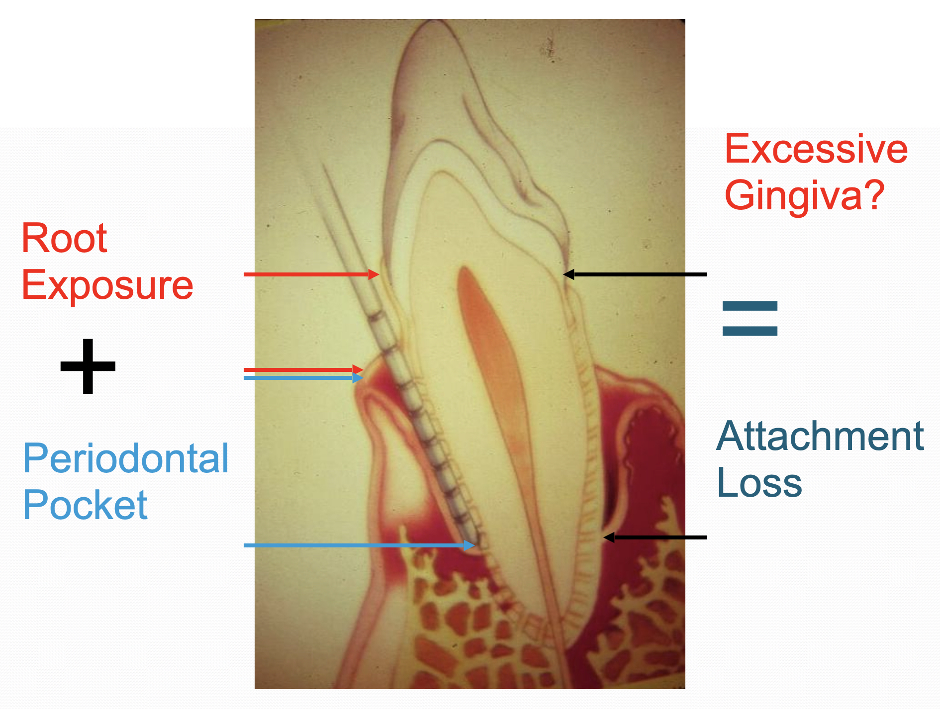It's also important to note attachment loss (AL) rarely equates to periodontal pocket depth (PP). Any root exposure (RE) and/or gingival enlargement (GE) should be noted. In cases of root exposure, PP+RE = AL. In Martel’s paper 6 comparing closed root planing (RP/C) of pockets 3-6mm in depth to perioceutic medications, RP/C was equal or better than perioceutic upon evaluation of the sites 3 months after the initial procedure. Within the paper, a RP/C site at the mesial aspect of the mandibular canine is shown with an initial PP depth of 3.5 mm resulting in PP of 2 mm at the 3-month follow-up. The photographs of the periodontal probe inserted into the pocket reveals there is an additional 1.5 mm of crown height now visible. This case of reduction of pocket depth resulted in no significant difference in attachment and instead, a PP reduction due to a decrease of pocket inflammation primarily through reduction of gingival enlargement. Closed root planing served to turn a pocket of active periodontal disease inactive. For a video on the differences between curettes and scalers and how they should be placed into the gingival sulcus, please visit: <https://tooth.vet/wvc-perio>.

While gain of attachment is a good thing, one must consider owner compliance with follow up veterinary anesthetic dental procedures with the goal to keep that attachment instead of active PD returning to the site. It is for this reason and the fact that periodontal surgery serves to remove the diseased pocket lining that the veterinary surgeon should prefer periodontal pocket depth reduction (over gain of attachment) as the preferred outcome in veterinary patients. Daily active home care and more regular anesthetic scaling and root planing (SRP) (COHAT) procedures are needed to maintain the attachment level. While there are no hard and fast rules, patients receiving advanced periodontal procedures to preserve PD4 teeth (such as GTR) should have their next anesthetic SRP in 3 months. Patients with PD3 teeth treated/preserved need their next SRP in 3-6 months. Patients with PD2 treated teeth need their next SRP in 6-12 months. Patients with remaining teeth only affected by gingivitis (PD1) need their next SRP in 9-12 months. Base your timeline on individual variations and breed/size periodontal predilections knowing that PD occurs faster in smaller patients.

Full mouth intraoral radiographs are needed on each pet and each tooth patient (typically 42 tooth patients in dogs and 30 in cats) receives their own treatment plan. After considering a patient’s comorbidities and knowing owner consent is needed prior to any treatment, most teeth presenting with PD4 require oral surgical extraction followed by periodontal flap therapy. Cases of vertical bone loss may have the potential to preserve the tooth through some of the periodontal therapies mentioned further in this document. A PD3 tooth can often go either way. Most PD2 teeth only require a form of root planing unless there are additional factors such as gingival enlargement contributing to an increased pocket depth. PD1 teeth are healthy with reversible gingivitis (reversible through SRP treatment) and no attachment loss.

While there can be tooth type and breed/size variations in establishing normal periodontal pocket depth, it is known that the typical sulcus depth is 1-3 mm in the dog as well as people and 0.5mm in the cat. A 3 mm pocket depth around a small breed dog’s incisor is a significant indicator of disease while a 4-6 mm pocket depth at a canine tooth of a giant breed dog may be completely normal and have a gingival index of 0. In essence, use logic when evaluating each case. Keeping owner compliance and patient comorbidities in mind along with tooth size variation, one can simplify the PP measurements to help decide what treatment is usually best:

* PP depths 1-4mm should receive closed root planing
* PP depths of 5 mm or more are best served by some form of open flap debridement surgery for an average patient. (As noted previously, 5mm may be normal in large breed while 3mm may be problematic in small teeth/breeds making this number variable based upon each situation.)

Part of the reason to consider open root planing which usually extends into some form of a flap and oral surgery is that it has been surmised that despite the best efforts with meticulous cleaning in closed pockets, residual plaque and calculus are still found at depths greater than 5mm.1,7 In other situations, a practitioner may not be cleaning the site as thoroughly, instead relying on the action of a perioceutic medication while under the false impression that the local antimicrobial will take care of the problem. The advantages to open flap treatments are:

-The ability to clean the root with direct visualization

-The resection of diseased pocket lining and treatment of soft tissues

-Allowing repair of the site typically with primary intention healing

-Evaluation of underlying/adjacent bone and treatment of bony defects if present

-Minimal alveolar bone resorption during healing

Once a flap is opened and the tissue treated depending on flap type and site indications, the tools used to treat the root and surrounding bone are hand curettes, serrated periosteal elevators or Miller bone curettes, specialized ultrasonics (Acteon H3 tip) on lower power setting so as not to damage the cementum, and diamond burs (usually medium grit). The tool of choice is dependent upon the site. Bony defects between and around teeth are one of the most common periodontal bone defects. A crater within alveolar bone (not bone that is a pocket wall) is a primary example of reverse or negative architecture which requires definitive osseous surgery. This is accomplished through resection or removal of bone to reestablish positive or normal physiologic bony architecture usually by reducing the defect walls so that the original depression becomes a leveled floor and the site is made smooth with harmonic slopes.

The proximal wedge technique (PWT) (https://tooth.vet/pwt) is a non-displaced flap to accomplish removal of pocket lining, removal of thickened or redundant tissue, and improve the underlying bony architecture. The result is a consistent reduction in pocket depth with maintenance of healthy gingival margin for at least a year. At minimum, this technique should always be considered and likely performed anytime an extraction of a mandibular third incisor is indicated.

In pockets with vertical bone loss, which is more common in the palatal aspects of maxillary canines, the intrabony defect provides the potential for regenerative procedures. Guided tissue regeneration (GTR) is the removal of irritants (calculus, bacteria, granulation tissue, and debris) to allow for the encouragement of PDL, bone, and cementum by excluding gingival tissues through the use of a barrier. We can simplify this by stating the goal is the formation of new bone through the use of a barrier membrane. Traditionally, a bone graft is used to aid in new bone formation, yet without a barrier, this is not likely to be successful as epithelial cells have been shown to migrate ten times faster than any other type of periodontal cell type.8 This means that GTR *must* have a barrier/membrane. Many types of barrier and graft products exist on the market with others becoming available to the veterinary industry each year. Becoming familiar with the properties and source of each of these products can aid in the practitioner’s selection of products. Many of the available products are reviewed in the lecture and listed within <https://tooth.vet/wvc-perio> in addition to the following summary:

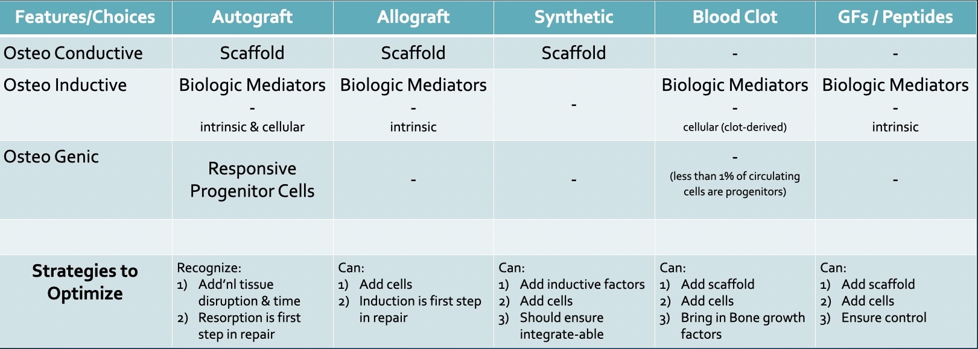

Grafts can have many sources as well as features. The most basic of features is osteopromotive: products that promote the formation of new bone. They may have osteoconductive surfaces which have topography that permit and encourage cellular attachment and migration. Both osteopromotive and osteoconductive surfaces are scaffolds with conductive surfaces having topography that cells recognize and like. Often, materials are augmented to be osteoinductive, meaning they have growth factors that induce stem cells. Osteogenic materials have living mesenchymal cells that are capable of forming bone (the patient’s own marrow). Almost all graft materials do not function as barriers/membranes. Recall that a barrier is required for GTR to provide protection of soft tissue in-growth.

Here is a list of many veterinary dental graft and/or barrier products with some features:

* Consil (Nutramax), osteopromotive bioglass
* Synergy (VTS), osteoconductive biphasic calcium phosphate with bone shape
* S-VetOss (BioMatCan), osteoconductive bioceramic calcium phosphate putty
* Cancellous bone block, osteoconductive real bone (allo- or xeno-graft)
* Osteoallograft Orthomix or Periomix (VTS), osteoconductive cancellous bone chips plus osteoinductive demineralized bone matrix (DBM). The DBM process exposes the native bone morphogenic proteins (BMPs). BMPs are growth factors that are involved in new bone formation and healing.
* Fusion Xpres Bone Putty (VTS) = Osteoallograft plus Synergy in a putty form
* Fortigen-P (VTS) = Osteoallograft with surface modifications of immobile BMP-2 providing the benefits with improved safety and reliable dosing of rhBMP-2.
* GemVet (VTS) = recombinant human platelet-derived growth factor (rh-PDGF), which is five times more chemotactic for mesenchymal cells than rhBMP-2. It is best combined with Osteoallograft for additional benefits to aid in healing.
* ReGum (BioChange, PRN), osteoconductive 3D scaffold with osteogenic properties in vivo while functioning as a barrier to prevent soft tissue in-growth.
* Fascia lata (VTS) is a processed and freeze-dried natural collagen scaffold that provides a membrane and guide. It can be used as a GTR barrier, to bridge defects such as cleft palates, or to close ONF sites.
* Ossiflex (VTS) is a thin flexible membrane made of natural demineralized cortical bone.
* Doxirobe (Zoetis) can be used to fabricate a custom-shaped liquid polymer membrane.9
* A blood clot (osteogenic) also has all of the products to form new bone.

Deciding among these products (usually a combination) to aid in bone augmentation for your patient can also vary based on the shelf-life, cost, availability, and material handling properties.

One of the most common GTR locations is the palatal aspect of the maxillary canines. Access to the palatal aspect of the maxillary canine tooth in order to perform GTR can be accomplished through a crescent flap10 or, alternatively, mesial and distal releasing incisions can be made as pictured. Pictures show 1) the granulation tissue within the 7mm infrabony pocket, 2) after removal of the granulation tissue with some additional open root planing needed, 3) placed osteoinductive Demineralize Bone Matrix (DBM) and osteoconductive cancellous bone chips (Osteoallograft Periomix, VTS) combined with the patient’s blood. A barrier and surgical closure (ideally with 5-0 poliglecaprone 25) are the remaining steps for this GTR site. GTR access of the mesial or distal mandibular first molar is typically accomplished through a single vertical releasing incision made overlying bone at a line angle,1,10 not at radicular midface locations.

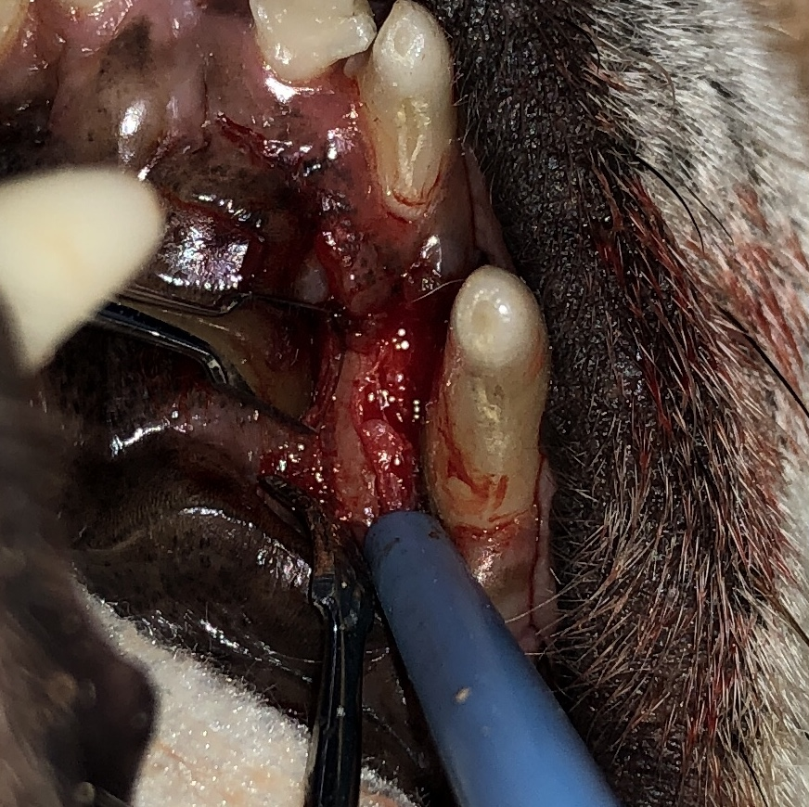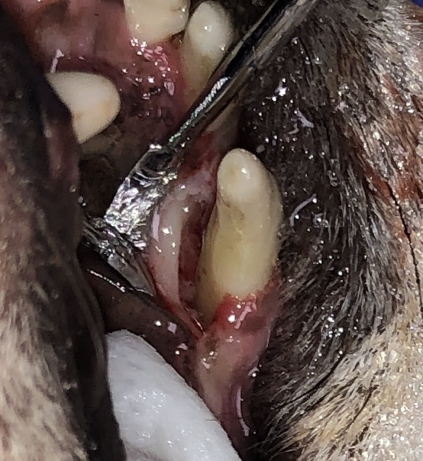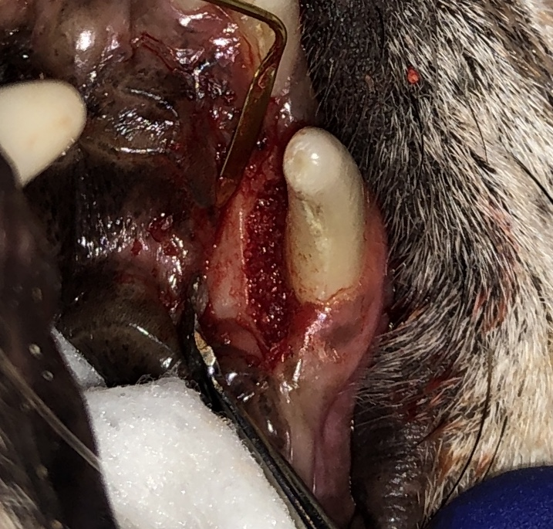

Patients that appear to have an infrabony pocket of a maxillary canine tooth may actually be an inapparent oral nasal fistula (ONF). Other patients with ONFs may have horizontal bone loss, communication between the maxillary third incisor and nose, and or significant gingival recession. Due to the significant bone loss with disease reaching the apex occurring in ONF cases, oral surgical extraction is known to be the best treatment. Periodontal flap closure of this site can be challenging and may require a revision procedure due the respiratory forces tugging on the unsupported soft tissues. The keys to success in ONF repairs are large, wide, *tension-free* flaps. Recall that mucosal tissues can elongate nearly ten times their original size once the underlying periosteum has been released. Most failures relate to inadequate flap release and remaining tension. A tension-free flap should allow the surgeon to set the cut margin in the final desired location and let go while viewing the tissue remaining in the same place without retracting (an indicator of tension).

ONF patients with drastic gingival recession and insufficient buccal mucosa may instead require one of the following: a) a two-stage procedure with extraction of adjacent premolars and/or incisors to provide additional healed soft tissue from which to create a wide tension free flap, b) a double layer flap technique: “the palatal edge of the defect provides the base or hinge, with the releasing incisions advanced palatally and joined across to provide a flap of sufficient size. The defect is prepared, with an attempt to preserve part of the tissue at the dorsal aspect of the defect to be the anchor for the edge of the palatal flap. The edges of the palatal flap are also secured. A buccal mucosa flap, extending from the lateral vestibule as a simple advancement flap is then closed over the site of the original defect as well as onto the harvest site of the palate,” c) a free auricular cartilage autograft11 or a freeze-dried fascial graft (VTS Fascia Lata), or d) a ReGum product in a mushroom shape (under study with BioChange/PRN).

References and Resources:

1Stepaniuk K. Periodontology. In: Lobprise HB, Dodd JR, eds. *Wiggs’s Veterinary Dentistry: Principles and Practice.* Hoboken, NJ: Wiley Blackwell; 2019:81. doi:10.1002/9781118816219.ch5

2Wallis C, Patel KV, Marshall M, Staunton R, Milella L, Harris S, Holcombe LJ. A longitudinal assessment of periodontal health status in 53 Labrador retrievers. *J Small Anim Pract.* 2018 Sep;59(9):560-569. doi:10.1111/jsap.12870. Epub 2018 Jul 13

3Carreira ML, Daniela D, Pedro A. Serum Ionized Calcium Quantification for Staging Canine Periodontal Disease: A Preliminary Study. *Top Companion Anim Med.* 2015 Jun;30(2):48-50. doi:10.1053/j.tcam.2015.07.002. Epub 2015 Jul 8

4Kortegaard HE, Eriksen T, Baelum V. Periodontal disease in research beagle dogs – an epidemiological study. *J Small Anim Pract.* 2008 Dec;49(12):610-6. doi:10.1111/j.1748-5827.2008.00609.x. Epub 2008 Sep 12

5Queck KE, Chapman A, Herzog LJ, Shell-Martin T, Burgess-Cassler A, McClure GD. Oral-Fluid Thiol-Detection Test Identifies Underlying Active Periodontal Disease Not Detected by the Visual Awake Examination. *J Am Anim Hosp Assoc.* 2018 May/Jun;54(3):132-137. doi:10.5326/JAAHA-MS-6607. Epub 2018 Mar 20.

6Martel DP, FoxPR, Lamb KE, Carmichael DT. Comparison of closed root planing with versus without concurrent doxycycline hyclate or clindamycin hydrochloride gel application for the treatment of periodontal disease in dogs. *J Am Vet Med Assoc* 2019 Feb 1;254(3):373-379. doi:10.2460/javma.254.3.373

7Choi YM, Lee J, Choi J, Joo J. Effect of root planing on the reduction of probing depth and the gain of clinical attachment depending on the mode of interproximal bone resorption. *J Periodontal Implant Sci.* 2015 Oct;45(5):184-9. doi:10.5051/jpis.2015.45.5.184. Epub 2015 Nov 2

8Mali R, Lele P,Vishakha. Guided tissue regeneration in communicating periodontal and endodontic lesions – A hope for the hopeless! *J Indian Soc Periodontal.* 2011 Oct-Dec;15(4):410-413. doi:10.4103/0972-124X.92582

9Alterman JB, HuffJF. Guided Tissue Regeneration in Four Teeth Using a Liquid Polymer Membrane. *J Vet Dent* 2016 Sep; 33(3):185-194. doi:10.1177/0898756416676564

10Lobprise HB, Stepaniuk K. Oral Surgery – Periodontal Surgery. In: Lobprise HB, Dodd JR, eds. *Wiggs’s Veterinary Dentistry: Principles and Practice.* Hoboken, NJ: Wiley Blackwell; 2019:193-228. doi:10.1002/9781118816219.ch10

11Lobprise HB. Oral Surgery – General. In: Lobprise HB, Dodd JR, eds. *Wiggs’s Veterinary Dentistry: Principles and Practice.* Hoboken, NJ: Wiley Blackwell; 2019:247-263. doi:10.1002/9781118816219.ch12

To find periodontal therapy lectures and additional training, including anesthesia, visit https://courses.vetceyoulluse.com/

Here are some step-by-step skills to practice on specimens:

1. Guided Tissue Regeneration (GTR): Select a maxillary canine tooth with an already existing palatal pocket or create an artifactual defect with a taper bur after flap creation. The above notes provide two suggestions for flap creation. The simplest one is an envelope flap created with two alveolar margin incisions. These incisions may extend all of the way to 1/203 and 1/205. Note the presence of a small branch of the palatal artery found midway in the diastema of the third incisor to canine. If the artery is encountered, some firm digital pressure for a matter of a few minutes usually slows the bleeding to normal tissue handling levels. The periosteal elevator is used to lift the flap along the palate. Using your zombie placed against the palatal bone to retract the flap can be done or stay suture(s) can be placed to retract the flap. Use your hand curettes and serrated periosteal elevator (Cislak EX-58S) or Miller bone curette (#9S) to gently\*\* clean the defect. If there is not defect, create one with a taper bur for lab purposes. Be aware this should be an infrabony pocket – ie the walls are the tooth or palatal bone. If there are not bony walls, graft material will not be held in place. This also means there must be a bony base. It is possible as you clean you may \*\*reveal (or create, but just say reveal) an inapparent ONF. ONF sites usually require tooth extraction instead of preservation (the opposite goal of GTR). You will likely be surprised on live patient how much effort it takes to clean this area. Tissue or calculus left behind is a site where bone will not return, thus GTR failure. Take a photo of the cleaned site with your phone and zoom in to verify it’s clean. Mix your Periomix bone graft with the patient’s serum, or GemVet, or PRP, or the patient’s blood. Use water for the lab. Get your water from the ultrasonic scaler. Using the EX 58S or Miller #9S or Beaver tail, place the Periomix into the prepared defect filling gently packing it in place. If there was an ONF, this would get sucked into the nose like sand. Cover with a membrane. This may be Ossiflex, Fascia Lata, Doxirobe (preferred), or ReGum. Without a membrane, the soft tissues will regrow into the defect before bone can form. Ie a membrane is an essential requirement of GTR. Alternatively, ReGum cone(s) can be placed in the patient’s serum, blood, PRP, or water for a few seconds, then press fit and trimmed to fill the entire defect. This is best reserved for furcation defects, but there may be a potential for repair with a very small ONF, as the narrow tip and wide base should prevent aspiration into the nose. ReGum acts as a membrane and the blood within the ‘ReGum scaffold’ will act to return bone to the site. Close the site with 5-0 monofilament sutures ensuring a tight *gingival* collar. LaGrange scissors may be needed to flatten a palatal tissue fold to give more coverage to the defect. If the gingival collar is loose, the defect will eventually recur.
   1. If time permits, repeat this process for the mesial aspect of the mandibular canine tooth. A single releasing incision is usually made at the mesial aspect of 3/407 and that tooth is extracted. Be careful not to remove hardly any buccal bone at distal 3/407 as that bony wall will be used to form the GTR walls.
2. Oral Nasal Fistula (ONF) Repair: Either working with the same maxillary canine as used for GTR or the opposite site, extract the canine +/- the first maxillary premolar. (Live patients would already be missing the canine tooth.) Fabricate the ONF defect to extend to the gingival mucosa (up to or past the MGJ). Decide on your flap plan before making any incisions: two vertical releasing incisions on either side, or two vertical releasing incisions with the distal one at the aspect of the now missing 1/205, or two releasing incisions with the mesial release being an extension of the mesial aspect of the defect. Other flap types can be made, but are beyond the scope of today’s lab. Create an alveolar margin incision. Use your periosteal elevator to lift the flap (Have a flat Arkansas stone handy). Also release the palatal tissue. Use LaGrange scissors (DO NOT USE to cut sutures) to cut the periosteum underlying the buccal mucosa. Blunt dissection is also helpful here. Be sure to trim BOTH flaps (buccal and palatal) margins to fresh edges. Use your tissue forceps to place the buccal flap to the palatal margin and release. If the flap stays in place, use 4-0 (occasionally 3-0) monofilament suture to close. The sutures that are over maxillary bone can be cruciate or simple interrupted. The ones overlying the defect can be horizontal mattresses and can have a second layer of simple interrupted sutures overlying. If the flap retracted upon release, more releasing of the mucosal tissues is required before suturing.

Any areas for which the flap is slid rostrally will be missing a gingival collar for closure. As long as the area is edentulous, this is fine and can be termed a split flap. If the area is not edentulous, there must be gingiva sutured surrounding the tooth or the tooth must be extracted.

Some ONFs have no/almost no palatal bone, thus you are suturing across an area that is suspending tissues over a defect that is ‘flapping in the breeze.’ These are likely to fail without a palatal hinge flap or VTS Fascia Lata (my favorite).