**What Lies Beneath…**

**Intraoral Radiographic Interpretation**

Jennifer Mathis, DVM, CVPP and Kristin I. Scott, DVM, DAVDC

Dental radiology has become the standard of care in veterinary dentistry.[1],[2],[3] Just having equipment doesn’t mean you know how to interpret what you are seeing or how to treat the tooth. For those of you still planning on acquiring equipment, knowing what can be found under the gumline will confirm the need for full mouth intraoral radiographs on every new dental patient.

The first step with oral radiology is orienting the films in the correct direction. While you may be familiar with Triadan numbering of teeth, here are a few helpful hints: “Do it *Right* the First Time.” “Always try to do your best- so be on *top*.” Remembering these mantras helps key you to recall the *top right* side (right maxilla) is the 100 quadrant. If you look at a pet face on, moving clockwise provides your 4 quadrants: 200 = left maxilla, 300 left mandible, 400 right mandible. Starting at the first incisor as #1, we number to the last tooth. There are typically 10 teeth in each maxillary quadrant, and 11 in each mandibular quadrant in the dog. Sometimes there are missing teeth. This means we cannot just start at 1 and count to 10 or 11, we need to use the rule of 4s and 9s. The canines are always 4s (104, 204, 304, or 404), the first molars are always 9s. Remember that the large upper tooth is not a 9 because it is the 4th pre molar (1/208) not the first molar (1/209). Counting forward or backward from the strategic teeth (canines and carnassials) in the mouth will help you number the teeth correctly.

Cats follow the same rules. They don’t have teeth beyond #9 in each quadrant. 109 and 209 in cats are very small and sort of hide behind 108 and 208. There are no 5s (no 105, 205, 305, 405) and no 6s in the mandibles (no 306, 406). An unexpected missing tooth in all species should be evaluated. A truly missing tooth is fine – it’s what lies beneath (usually hidden) that could cause issues. Is the missing tooth present impacted? Is there a retained tooth root? A cyst? This is the essence of dental radiology – to look at the 60+% of each tooth “patient” below the gumline. Research shows 72.6%[4] to 86.1%[5] of intraoral radiographs provide essential or additional findings beyond visual disease noted during oral exams. Furthermore, 41.7% of radiographs of clinically unaffected teeth yielded incidental new findings4 or unexpected important lesions.5

We want to orient our films to have the crowns in the mouth. The easiest way is to think of the images laid out like a Cheshire cat grin:

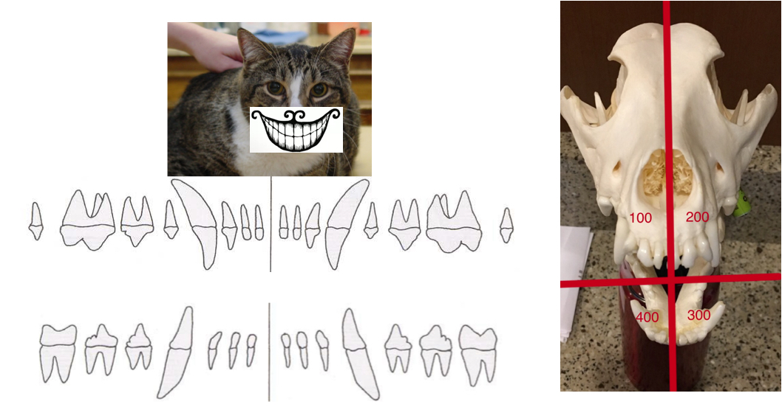1) Decide if the image is maxillary or mandibular. The white line formed by the dorsal plate of alveolar process of the maxilla will help you decide. Also, the mandibular canal can be seen on most mandibular films.

2) Rotate the image so the crowns are in the mouth. The maxillary roots should be pointing up and the mandibular roots pointing down. ***Don’t ever flip a digital image over, only rotate.***

3) Decide if it’s a left or right image. The hint for the upper 4th premolar is to use your thumb and first two fingers to mimic the tooth root. If it matches your left hand, then it’s the patient’s upper left 4th premolar (208) and vice versa for right and 108. If it is a view of incisors or canines, think ‘shaking hands’: their right is on your left, and vice-versa.

As you know, the layers of a tooth are enamel (or cementum below the gumline), dentin, and pulp. When looking at each image, identify the pulp (less dense canal in the center of each tooth), find and follow the periodontal ligament (grey line) around each tooth root.

Normal structures are shown below:[6] 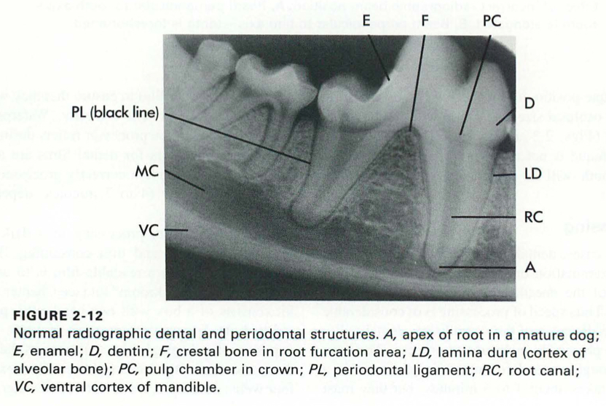

**Radiographic abnormalities:**

Retained tooth roots – Many times intraoral radiographs will reveal retained tooth roots and decisions must be made what to do about them. If the patient is symptomatic, redness is present, lysis is seen at/around the tooth root, or one can probe through the gum tissue, then removal of the root is needed. If this is incidental and there are no symptoms such as a reddened incomplete gingival covering and/or periapical lysis around the root, then removal would entail extensive oral surgery. You may be able to continue to monitor on future preventative care dental procedures, with communication to the owner. **Always remember to take post extraction radiographs to verify there are no retained tooth roots. Retained tooth roots have been found to be one source of the 55% of orally caused inflammatory rhinitis.7 This reminds us that in cases of eye and nasal issues, we should ensure full radiographic imaging is performed as oral issues can relate.

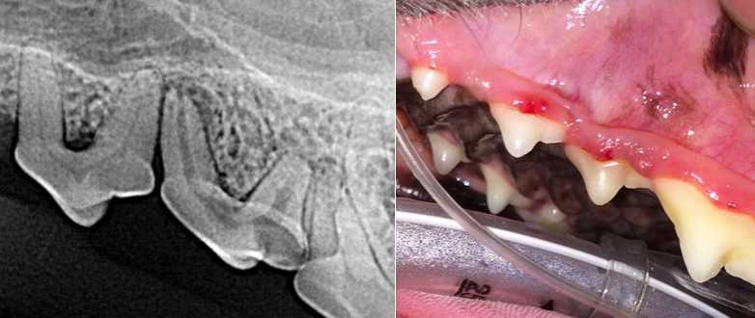Widened pulp - look at surrounding teeth. (Don’t forget about comparing to the opposite side.) A widened pulp is usually a tooth that is dead/non vital. As the tooth ages, dentin is laid down and the pulp narrows. A wide pulp is a tooth that has stopped aging. Many of these teeth are discolored. Most discolored teeth (92.2%)8 have pulp necrosis. Interestingly, only 57.1% of these had radiographic signs of pulp necrosis thus radiographs should not be relied upon to decide if the discolored tooth is vital.8 You can also transilluminate these teeth to provide additional information. All discolored teeth should have root canal therapy or extraction.

**Radiographic pitfalls:**

Foramen overlying a tooth apex: especially around first and second mandibular premolars.

A normal widening of the periodontal ligament based on tooth size or angle of image: chevron image – often seen with mandibular first molars superimposed over the mandibular canal, or some maxillary teeth over the nasal passages.

**Other findings of note:**

Deciduous teeth (add 400 to their typical Triadan number): have thinner roots and usually smaller crowns than their “adult” counterpart. In a 6-month old patient, the permanent root will have a wide pulp canal with thin dentinal walls and an open apex whereas a deciduous tooth will have a thinner root but be more developed. Sometimes a persistent deciduous tooth will have no permanent tooth to replace it: if it is stable, it can remain functional for that patient.

Supernumerary teeth: two of the same “adult” tooth.

Gemination teeth: a wide tooth that is like two teeth fused together (conjoined twins).

“Male” teeth: (supernumerary roots) some teeth have additional roots than what is anatomically standard (a third root). This is an important consideration with extraction planning and one of the reasons radiographs are always needed after an extraction.

These extra or unusual teeth as noted above may result in crowding and alignment issues, which lead to periodontal disease. If there is no crowding, alignment issues, nor periodontal disease, no treatment is needed at this time.

We will practice using the 7 Steps of Intraoral Radiographic Evaluation:

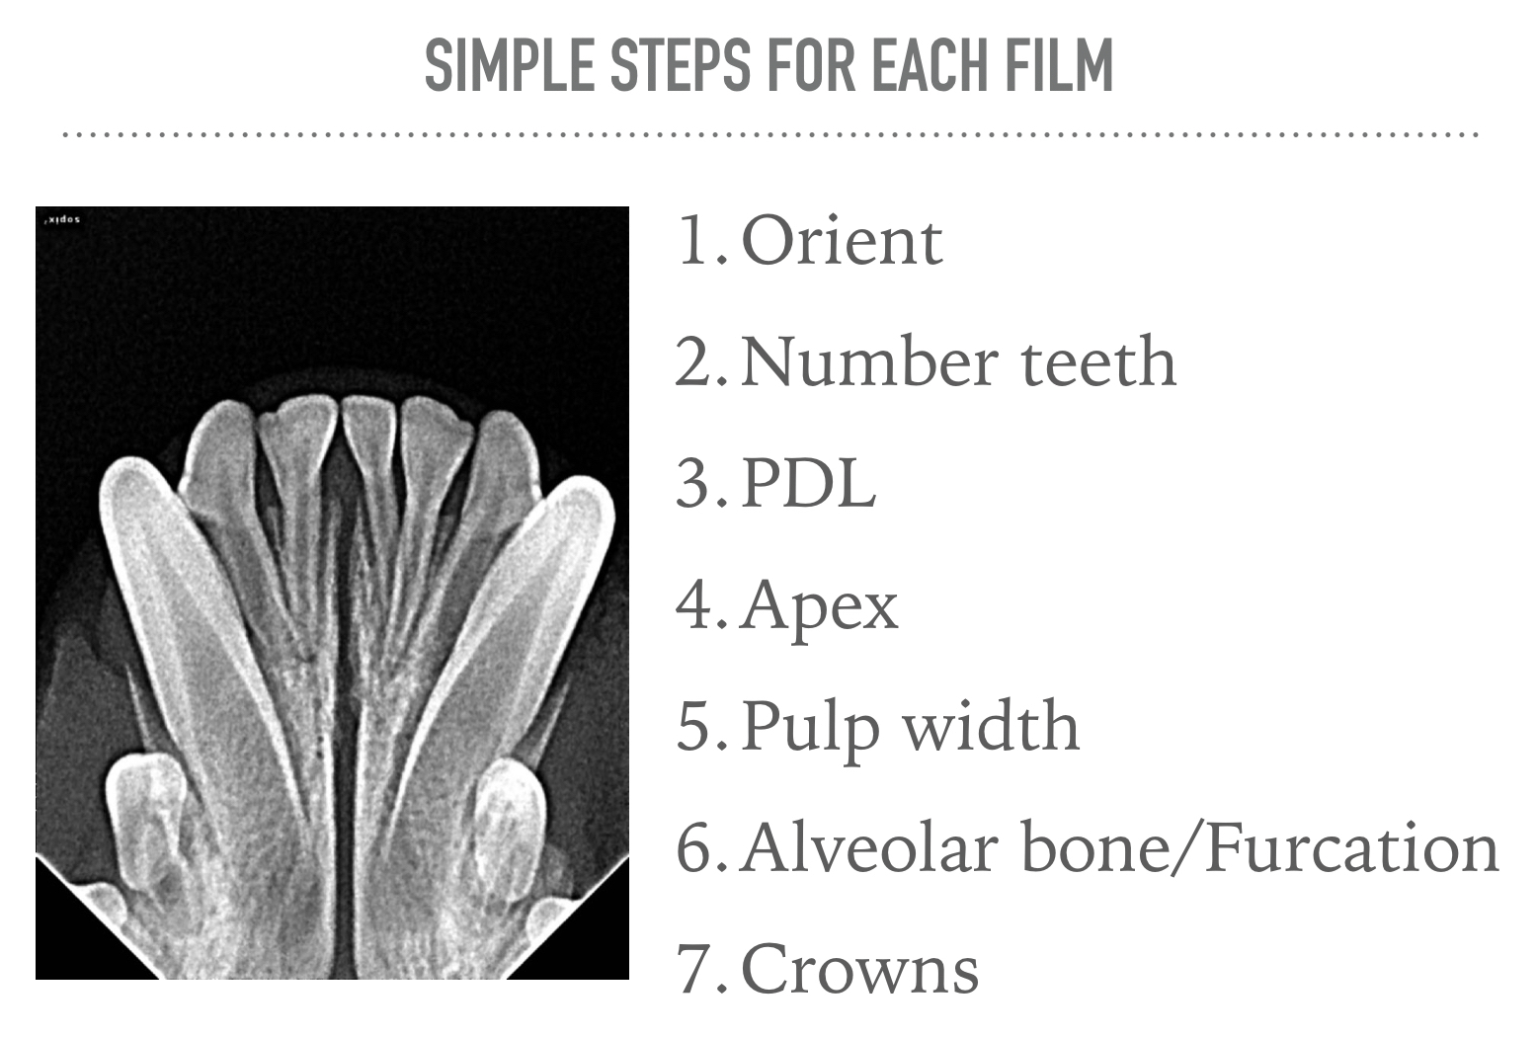

1. Bellows J, Berg ML, Dennis S, Harvey R, Lobprise HB, Snyder CJ, Stone AES, Van de Wetering AG. 2019 AAHA Dental Care Guidelines for Dogs and Cats. J Am Anim Hosp Assoc 2019 Mar/Apr; 55(2):49-69. doi: 10.5326/JAAHA-MS-6933
2. AVMA PLIT: Professional Liability Newsletter Vol 34, No3, Summer 2015, pg 1-4, *AVMA PLIT* (website): https://www.avmaplit.com/uploadedfiles/avma_plit/education_center/private_resources/library/publications/professional_liability_summer2015_web_safe.pdf
3. Holmstrom SE, Frost Fitch P, Eisner ER. Dental radiology, In: Veterinary Dental Techniques for the Small Animal Practitioner, 3rd ed., Holmstrom SE, Frost Fitch P, Eisner ER, eds., Saunders, Philadelphia, PA, pg132, 2004.
4. Verstraete FJ, Kass PH, Terpak CH. Diagnostic value of full-mouth radiography in dogs. Am J Vet Res 1998:59(6):686-691.
5. Verstraete FJ, Kass PH, Terpak CH. Diagnostic value of full-mouth radiography in cats. Am J Vet Res 1998:59(6):692-695.
6. Harvey CE, Emily PP. Small Animal Dentistry, Mosby, St. Louis, MO, pg34, 1993.

   7 Stepaniuk KS, Gingerich W. Suspect Odontogenic Infection Etiology for Canine Lymphoplasmacytic Rhinitis, J Vet Dent 32(1):22-29, Spring 2015. doi: 10.1177/089875641503200103

   8 Hale FA. Localized Intrinsic Staining of Teeth Due to Pulpitis and Pulp Necrosis in Dogs, J Vet Dent 18(1):14-20, Mar 2001. doi: 10.1177/089875640101800102